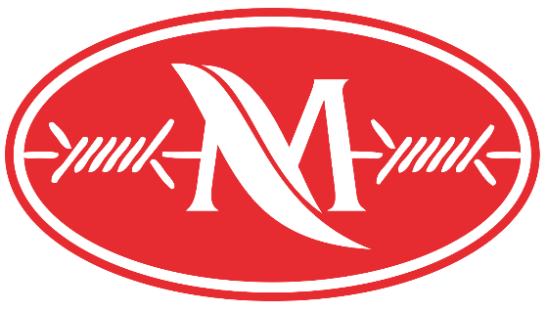
Maline Seed & Fence
77865 RD 414
Gothenburg, NE 69138
(308) 529-0781
malineseeds@gmail.com
malineseeds@gmail.com

- Lessee will pay a deposit on the tool (ST400i) of $1000. The $1000 minus the shipping fee and minus the accumulated rental fee of the greater of either $25 per day or $75 minimum, will be returned to Lessee upon return of the tool. Lessee will pay the cost of shipping to return the tool as well.
- All rental rates per day. Days apply to days in possession of Lessee. When the tool arrives at Lessee’s address, days start counting towards the lease the following day. The last day that counts is the day before the tool is sent back on UPS. Days in transit with UPS do not count as rental days.
- Staples must be purchased by Lessee from the Lessor.
- If the above equipment arrives to Lessee in damaged condition, Lessor must be notified immediately or Lessee will be responsible for any damage to equipment.
- Lessee agrees to care for the Equipment properly, to use it within its rated capacity, to restrict its use to Lessee’s qualified personnel and to prohibit anyone other than Lessor’s authorized personnel to repair the Equipment and to notify Lessor immediately of accidents, disabilities, failures or like information concerning the Equipment. Lessee further agrees to pay for all damage to the Equipment resulting from improper use or abuse of the Equipment upon receipt of invoices therefore from Lessor for Lessor’s costs and expense of repair.
- Lessee agrees to return tool at Lessee’s expense to Lessor’s location in same condition as when received by Lessee, reasonable wear and tear expected. Scratches are ok, smashed or bent equipment is not ok. Any tool kept more than 28 days becomes the property of the Lessee and no money will be returned.
- Lessee assumes all risk and liability for and agrees to indemnify, save and hold Lessor harmless from all claims and liens all loss, damage, claims, penalties, liability and expense, including attorney’s fees, howsoever arising or incurred because of the Equipment or the storage use or operation thereof. Lessee at its own expense shall carry adequate public liability insurance against bodily injury, including death, and against property damage.
- This is a contract of rental only and nothing herein conveys to Lessee any right, title or interest in or to any of the Equipment, except as a Lessee.
- Safety instructions are provided with the tool. If the safety instructions for the tool are lost, they are also viewable online at www.stockade.com.
- Basic operator instructions are also viewable online at www.stockade.com.
CUSTOMER’S ACCEPTANCE
I understand fully the proper and safe operation of this equipment. I have read this rental agreement and agree to the terms and conditions set forth. I have read and agree to abide by the safety instructions for the tool before attempting to operate the tool.
Customer’s Signature (Lessee)_________________________________________ Processed by:

